***Experiment 8 Output***

**Aim:** This experiment covers managing users, permissions, and security policies with AWS IAM. It uses **Docker, LocalStack,** and **AWS CLI** to simulate **IAM** in a local cloud setup, focusing on access controls, policies, and roles.

***Creating IAM User***

***Creating Roles***

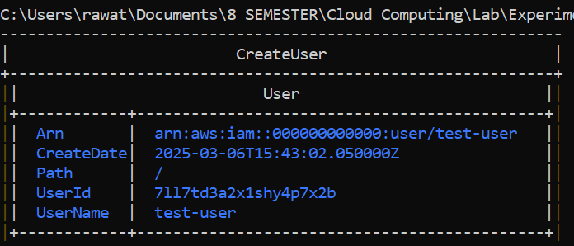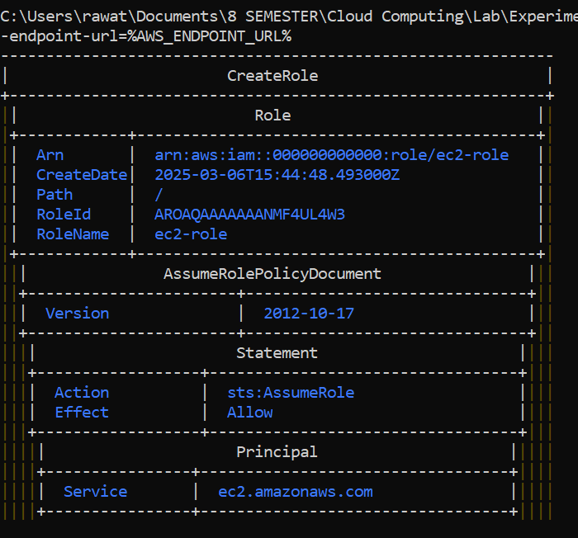

**Fig 1: IAM User**

***Listing Users***

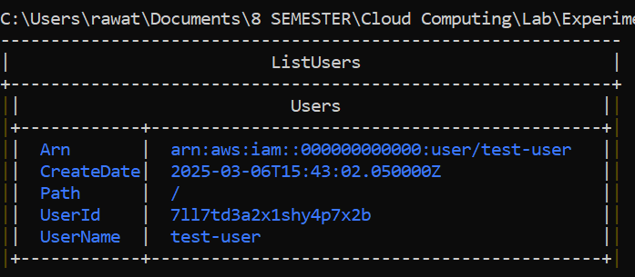

***Listing Roles***

***Fig 2: Roles Table***

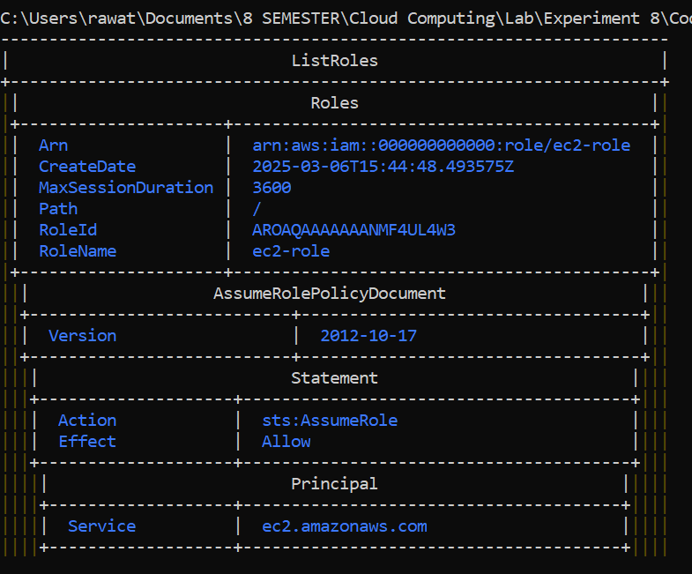

***Fig 3: Users List Table***

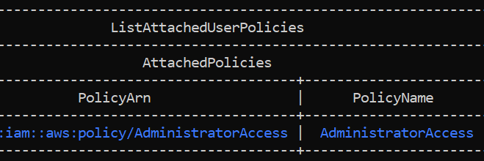

***Listing Policies***

***Fig 4: Policies List Table***

***Fig 5: Roles Output***